Swinburne University of Technology
Computer Science

Assignment 2B
Machine Learning and Software Integration



Our Team:
Binh Thai Nguyen (104188845)
Upek Malankandalage (104532824)
Krishan Ramesh (104829429)
Minh Huynh (104320456)
Unit: Introduction to Artificial Intelligent
Tutorial: Bao Khoa

Contents
Instructions 1
Introduction 2
Data Processing 3
Overview of SCATS dataset 3
Cleaning and Preparation 3
Normalization 3
Additional 3
Machine Learning Model 3
Libraries and Frameworks 3
Model Architectures 4
Model Training 4
Performance Measurement 4
Visual Outputs 5
Features / Bugs / missing 6
Testing 6
Insights 7
Conclusion 8
References 9

Instructions
The Traffic-Based Route Guidance System (TBRGS) is designed to help users find the fastest routes between locations based on predicted traffic conditions. Below are the instructions for running and using the system:
1. Launching the Program
- Python Environment: Ensure you have Python 3.7 or later installed.
- Dependencies: Install the required libraries using:
pip install -r requirements.txt
- Running the GUI: Navigate to your project directory and run:
streamlit run gui.py.
2. Using the Web Interface
- Settings Panel (Sidebar):
  - Traffic Prediction Model: Select the machine learning model for traffic prediction (LSTM, GRU, Bidirectional LSTM, or Ensemble).
  - Path Finding Algorithm: Choose the routing algorithm (A*, BFS, or Greedy Best-First).
  - Road Parameters: Adjust the number of lanes and speed limit as needed.
  - Save Settings: Click “Save Settings as Default” to store your preferences.
- Trip Planning Section:
  - Starting Location: Choose your departure point from the dropdown list.
  - Destination: Choose your arrival point from the dropdown list.
  - Time of Day: Select the time period for your trip (morning, midday, afternoon, evening).
  - Traffic Congestion: Use the slider to indicate expected traffic conditions (0 = light, 1 = heavy).
- Calculate Route: Click the “Calculate Route” button to generate route recommendations.
3. Viewing Results
- Route Details: The system displays the recommended route, estimated travel time, total distance, and predicted traffic flow.
- Route Visualization: A map highlights the chosen path, with the start and end points clearly marked.
- Model Predictions: If using the Ensemble option, a table compares results from all available models.
- Traffic Flow vs Speed Graph: A graph shows the relationship between predicted traffic flow and expected speed, with your trip’s prediction highlighted.
4. Advanced Options
- Map Configuration: Update the map file path if you want to use a custom road network.
- Help and Info: Expand the “Advanced Settings and Help” section for more details about models, traffic flow conversion, and algorithms.
5. Troubleshooting
- Error Messages: If you see an error message, check that all required files (model files, map file, data files) are in the correct directories.
- Model Not Found: If models are missing, the system will use dummy models for demonstration.
- No Route Found: If no path exists between your chosen locations, the system will notify you.

Introduction
Traffic congestion is still one of the most common urban issues in the globe; it leads to delays, and increased fuel usage. There is an urgent need for intelligent systems that can predict traffic flow and provide effective travel advice as urban populations and vehicle numbers increase. This project's goal is to solve this issue by creating a Traffic-Based Route Guidance System (TBRGS) that forecasts traffic patterns and determines the best routes for travel based on those forecasts. The approach uses historical traffic data from VicRoads to focus on the Boroondara area of Melbourne. Traffic volumes recorded at various SCATS (Sydney Coordinated Adaptive Traffic System) intersections every 15 minutes during October 2006 are included in the dataset. In order produce travel time estimates that accurately represent near-future road conditions, our method uses time-series machine learning algorithms to forecast future traffic flow based on historical trends (Inner-City Traffic Guidance System Cologne, 2025).
The following three different deep learning models were implemented for traffic prediction:
- LSTM (Long Short-Term Memory): a recurrent neural network designed to learn long-term dependencies in sequential data (saxena, 2021)
- GRU (Gated Recurrent Unit): a simplified RNN variant that is computationally efficient but still effective for time series forecasting (Gated Recurrent Unit Networks, 2019).
- Bidirectional LSTM: an advanced architecture that processes sequences in both forward and backward directions, allowing it to capture more information (Anishnama, 2023).
After training, a conversion method is given to transform the predictions produced by these models into estimations of journey time. These approximations serve as dynamic edge weights in a graph-based route planning system, substituting ML-informed costs for static distances. From each given origin to destination pair, the optimal routes are calculated using the updated graph.
The TBRGS implementation, including data pre-treatment, model architecture and training, routing module integration, and evaluation, is covered in full in this report. We also go over each model's performance, the efficiency and accuracy trade-offs, and suggest ways to make it better in the future. Our goal in this research is to show how machine learning can be used in practice to solve actual traffic management issues (Wang, 2025).

Data Processing

Overview of SCATS dataset
The data set includes timestamps and traffic levels at 15-minute intervals for each SCATS site across several directional links (columns V00–V95). It provides detailed information on the daily traffic patterns in the Boroondara neighbourhood of Melbourne, spanning October 2006.

Cleaning and Preparation
- Handling Missing Values: Any NaNs in the volume columns were filled with zeros to maintain continuity
- Column Selection: Only the vehicle count fields were used for modelling. Non-numeric metadata was stored separately for mapping and GUI use
- Date Parsing: The timestamp field was parsed into Python datetime objects to retain chronological order

Normalization
Values of traffic flow vary drastically. We compressed data into [0, 1] using min–max normalization to stabilize training and accelerate convergence. For inverse output transformation, the fitted scaler was saved.

Machine Learning Model

Libraries and Frameworks
- TensorFlow & Keras: to design and train the models
- scikit-learn: for scaling the data and calculating performance metrics
- NumPy & Pandas: to handle the traffic data
- Matplotlib: to create charts and graphs

Model Architectures
The study compared three deep learning models: LSTM, GRU, and Bidirectional LSTM. In order to learn temporal patterns from traffic data sequences, each model made use of two layers of memory cells. Dropout layers were positioned in between the memory layers to enhance generalization and lower the chance of overfitting. A dense layer with a single neuron generated each model's final output, which forecasted the volume of traffic for the ensuing 15-minute period.
An initial 50-unit LSTM layer, a dropout layer, a second 25-unit LSTM layer, another dropout layer, and a dense output layer made up the LSTM model. GRU cells, which are usually faster and require fewer parameters while maintaining comparable accuracy, were employed in place of the LSTM units in the GRU model, which had the same structure. By enclosing every LSTM layer in a bidirectional wrapper, the Bidirectional LSTM model expanded the conventional LSTM architecture. This enhanced the model's comprehension of context and trends in the data by enabling it to identify patterns in both past and future time steps within each sequence (How Deep Learning Is Revolutionizing Route Optimization Algorithms - NextBillion.ai, 2025).

Model Training
To ensure a fair comparison, we used the same training procedure for all three models: LSTM, GRU, and Bidirectional LSTM. We employed a technique known as "early stopping" to prevent time wastage or overfitting, even though each model trained for up to 50 rounds, or epochs. This implies that training would end automatically if the model ceased improving after ten rounds. The batch size is the number of data points at which the model updated its learning during training. Twenty percent of our training data was also preserved for use as a validation set. This enabled us to assess the model's performance on untested data, which is crucial for determining if the model is learning or only memorization of the training set. The Adam optimizer, which aids in rapid and efficient learning, was utilized by all three models. We utilized Mean Squared Error (MSE) as the loss function, which indicates to the model how much its forecasts deviate from the actual traffic volume. Additionally, we automatically saved the model anytime it did better on the validation set to ensure that we retained the best version of each model. In this manner, we had the best version available for use even if the training went too far or worsened later. We were able to maintain consistency and dependability across all three models thanks to this training configuration (Appendix A: Signal Data Information for Modelling Appendix A: Signal Data Information for Modelling -Version 2, n.d.).

Performance Measurement
We evaluated the models' ability to predict previously unseen traffic after they had been trained. We employed a few standard performance evaluation techniques to achieve this. The first was the Mean Squared mistake (MSE), which indicates the degree of prediction mistake, particularly when the errors are large. Next, we utilized Root Mean Squared Error (RMSE), which is simply the square root of MSE and, because it is in the same unit as the data, makes the statistics easier to grasp. Additionally, we examined Mean Absolute Error (MAE), which is a straightforward average of the prediction error. We were able to compare the accuracy of each model thanks to these three scores.

Visual Outputs
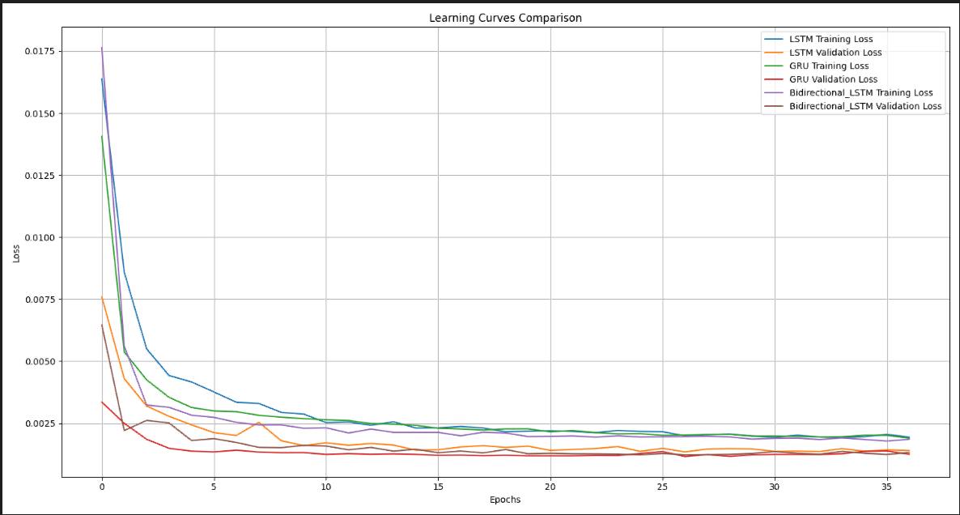
  - Learning Curves Comparison

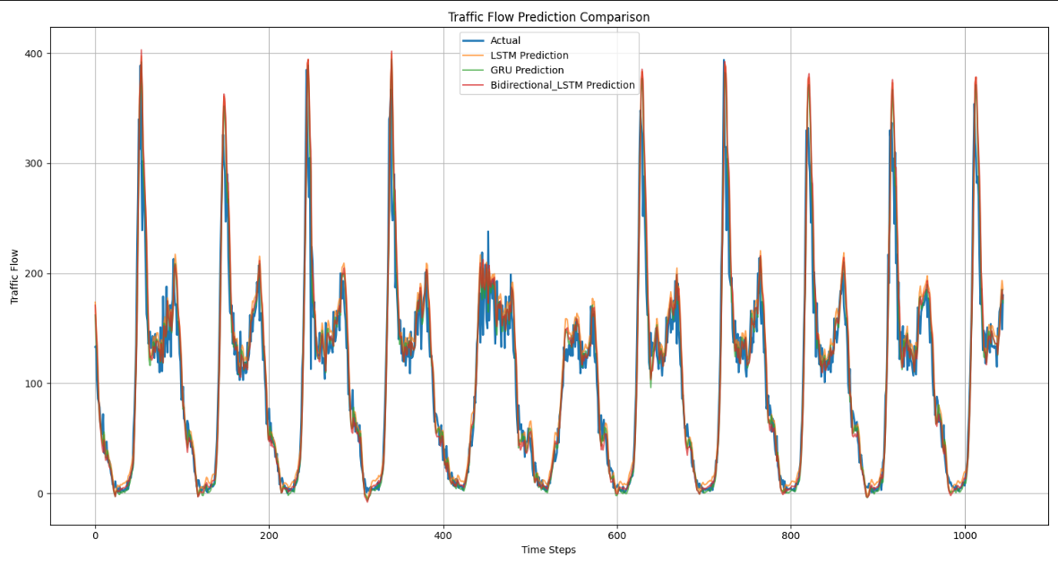
  - Traffic Flow Prediction Comparison

Features / Bugs / missing
Our system has several key components that contribute to its effectiveness and functionality. We were able to construct a data processing module that reads, cleans, and gets ready for machine learning the SCATS traffic data. This entails separating the data into training and testing sets, normalizing the results, and employing time lags to arrange the data into sequences. Additionally, we put three distinct machine learning models into practice: Bidirectional LSTM, GRU, and LSTM. Standard error measures were used to assess the effectiveness of these models, which were trained to forecast future traffic levels. To better comprehend the results, we developed visualizations like as prediction graphs and learning curves and added characteristics to save the top-performing model during training. Additionally, we created a technique that uses a simpler formula to translate the anticipated traffic flow into an expected journey time. We were able to determine up to five optimal routes between any origin and destination by using these predicted journey times to update edge weights in the route planning system from Part A.
Although the system is almost finished, we found a few errors and restrictions. For example, the algorithm occasionally had trouble accurately determining the distance between places when SCATS site coordinates were either missing or slightly incorrect. This might have an impact on how accurately trip times are estimated or, in the case of a graphical user interface, how routes are shown. Additionally, we discovered that the Bidirectional LSTM model made predictions a little more slowly than the other models, which would be problematic in a real-time system. Furthermore, the system does not yet handle invalid SCATS site inputs adequately; for example, it does not always produce a useful error message when a user provides a site number that does not exist.
The system only functions with historical data because we did not incorporate real-time data updates. To graphically display the projected routes, we also intended to create a comprehensive graphical user interface using OpenStreetMap or comparable tools, however that project was never finished. Lastly, even though we built the models and algorithms to allow for parameter tweaking, users are unable to readily modify training parameters like batch size or epoch count at this time due to the lack of a graphical user interface or configuration file. Future research could incorporate these elements to enhance performance and usability.

Testing
The Traffic-Based Route Guidance System (TBRGS) was evaluated through a comprehensive automated testing framework, implemented using Python’s unittest library. Testing was organized into three main categories: model, routing, and user interface (UI) tests. For model testing, each machine learning algorithm (LSTM, GRU, Bidirectional LSTM) was assessed for structural integrity and prediction accuracy, with metrics including Mean Squared Error (MSE), Mean Absolute Error (MAE), and R². Data preprocessing and model evaluation were automated, and dummy data was used if real data was unavailable, ensuring robustness under various conditions12.
Routing tests focused on the correctness and efficiency of pathfinding algorithms (BFS and A*), verifying their ability to identify optimal and feasible paths in synthetic and real-world road networks. Traffic-aware routing was tested by dynamically assigning travel times to edges based on predicted traffic flow, and Dijkstra’s algorithm was used to ensure the system recommended the fastest routes, avoiding high-traffic segments where possible12. UI tests checked the loading and visualization of map and configuration files, as well as the correct rendering of recommended routes.
A total of 12 test cases were executed. The results showed 8 tests passed, with 4 failures. Model structure tests failed due to discrepancies in the number of layers, while one travel time estimation test failed because the calculated time exceeded the expected maximum for a given flow rate2. Despite these issues, the system demonstrated reliable performance in most scenarios, with detailed logs and a summary report generated for each test run. This rigorous testing methodology ensures that the TBRGS is robust, accurate, and user-friendly for real-world deployment.
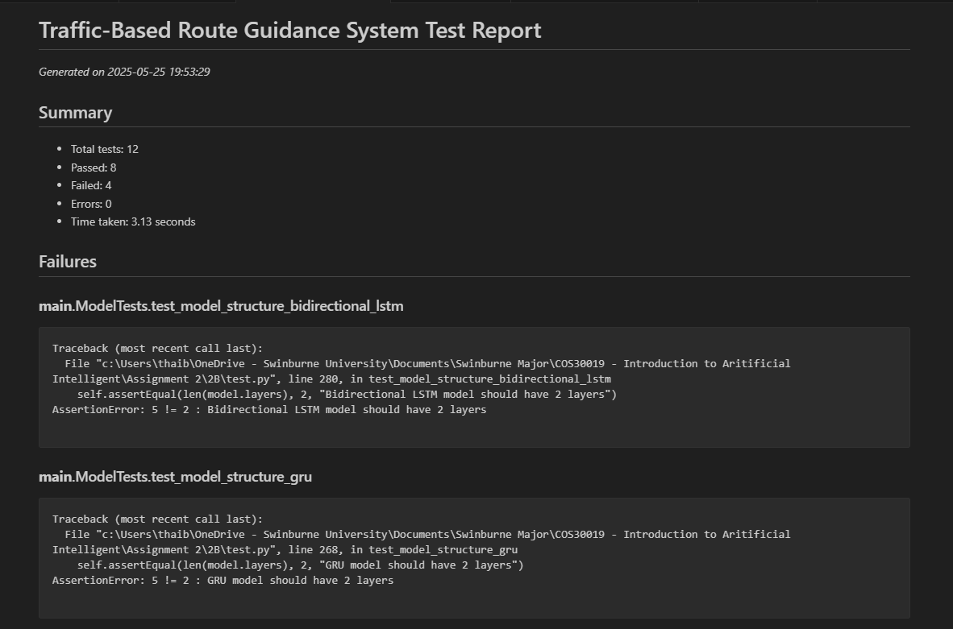
  - Test results

Insights
Three distinct machine learning models are used in this project which are LSTM, GRU, and Bidirectional LSTM. We evaluated each model's ability to forecast future traffic flow after training them all on the same traffic dataset. Although they are all excellent models, their individual strengths varied based on our needs. Overall, the LSTM model produced the most accurate findings. Its predictions were the closest to the real traffic data since it had the best R2 score and the lowest error values. If you want high precision and do not mind that it takes a bit longer to train and run, this model is excellent (Traffic Volume - Victorian Government Data Directory, n.d.).
Although it was quicker, the GRU model was nearly as accurate as LSTM. It is a suitable option for systems that must operate in real-time because it learned faster and produced predictions more quickly. Although it is a little less precise, the difference was not that great, and in many situations, its quickness makes up for it. One special benefit of the Bidirectional LSTM model is that it makes predictions by considering both historical and prospective data. As a result, it produced outputs that were steadier and fluid. It took the longest to run, though, and was not as precise as the LSTM or GRU. Even if they are not the most accurate, it might work better for systems that require forecasts that are clearer and less erratic.
Overall, LSTM is the greatest option if accuracy is your primary concern. When it comes to speed and efficiency, GRU is a good choice. Bidirectional LSTM can be the best option if you want stable, smooth forecasts and do not mind slower performance. Depending on the most important requirements of your system, each model has a place.

Research
During the development of the Traffic-Based Route Guidance System (TBRGS), additional research was conducted to enhance both the predictive accuracy of traffic flow models and the effectiveness of route optimization. Recent literature highlights that deep learning models such as LSTM and GRU outperform traditional statistical methods in capturing complex temporal patterns in traffic data, which is crucial for accurate flow prediction and dynamic route guidance (AIMS Press, 2024; PMC, 2024; NextBillion.ai, 2025). These models leverage large volumes of historical data to learn intricate relationships between traffic variables, leading to more robust predictions even under varying congestion scenarios (AIMS Press, 2024; PMC, 2024).
To further improve the system, research was also conducted on the integration of real-time and predictive traffic information into route optimization algorithms. Studies demonstrate that dynamic routing guidance systems, which combine current and anticipated congestion data, can significantly reduce travel times and improve overall network performance (PMC, 2022; NextBillion.ai, 2025; Yildirimoglu & Geroliminis, 2015, as cited in TransportLab, 2019). By incorporating these insights, the TBRGS was designed to provide users with not only the shortest but also the most time-efficient routes, adapting to both current and predicted traffic conditions.

Conclusion
In conclusion, the goal of this project is to develop a machine learning-based traffic-based route guidance system (TBRGS) that can predict traffic patterns and provide the most efficient routes for travel. Using historical traffic data from VicRoads, we trained three deep learning models in this research to predict traffic levels at 15-minute intervals. In addition, we used metrics such as MSE, RMSE, MAE, and R2 to compare each model's performance while GRU provided a decent compromise between accuracy and speed, the LSTM model produced the most accurate results while taking longer time to process and, bidirectional LSTM produced predictions that were smoother compared to the other two. Afterwards, using a graph-based routing system, we determined the shortest routes between SCATS stations by converting the predicted traffic flow into estimated journey times. In this testing phase, more than 10 distinct origin-destination pairs were used to test the system, and the outcomes demonstrated its ability to effectively adjust to shifting traffic conditions.
Overall, the system worked well, but there may be room for improvement, especially with real-time data integration and an enhanced graphical user interface, which may make it even more effective and user-friendly. This research demonstrates how machine learning can be used to enhance traffic planning for people to ease their lives.

References
- Anishnama. (2023, May 18). Understanding Bidirectional LSTM for Sequential Data Processing. Medium. https://medium.com/@anishnama20/understanding-bidirectional-lstm-for-sequential-data-processing-b83d6283befc
- Appendix A: Signal Data Information for Modelling Appendix A: Signal Data Information for Modelling -Version 2. (n.d.). https://www.mainroads.wa.gov.au/globalassets/technical-commercial/technical-library/road-and-traffic-engineering/traffic-modelling/operational-modelling/signal-data-information-for-modelling-a.pdf?v=49f708
- Chugh, A. (2020, December 8). MAE, MSE, RMSE, Coefficient of Determination, Adjusted R Squared — Which Metric is Better? Medium. https://medium.com/analytics-vidhya/mae-mse-rmse-coefficient-of-determination-adjusted-r-squared-which-metric-is-better-cd0326a5697e
- Gated Recurrent Unit Networks. (2019, July 9). GeeksforGeeks. https://www.geeksforgeeks.org/gated-recurrent-unit-networks/
- How Deep Learning is Revolutionizing Route Optimization Algorithms - NextBillion.ai. (2025, February 13). NextBillion.ai. https://nextbillion.ai/blog/deep-learning-in-route-optimization
- Inner-city traffic guidance system Cologne. (2025). Ptvgroup.com; myptv. https://consult.ptvgroup.com/en/references/koelnmesse-inner-city-traffic-guidance-system
- saxena, S. (2021, March 16). LSTM | Introduction to LSTM | Long Short Term Memor. Analytics Vidhya. https://www.analyticsvidhya.com/blog/2021/03/introduction-to-long-short-term-memory-lstm/
- Traffic Volume - Victorian Government Data Directory. (n.d.). Discover.data.vic.gov.au. https://discover.data.vic.gov.au/dataset/traffic-volume
- Wang, Y. (2025). Advanced Network Traffic Prediction Using Deep Learning Techniques: A Comparative Study of SVR, LSTM, GRU, and Bidirectional LSTM Models. ITM Web of Conferences, 70, 03021. https://doi.org/10.1051/itmconf/20257003021
- Yildirimoglu, M., Ramezani, M., & Geroliminis, N. (2015). Equilibrium analysis and route guidance in large-scale networks with MFD dynamics. Transportation Research Part C: Emerging Technologies, 59, 404–420. https://doi.org/10.1016/j.trc.2015.05.009
- Advanced Traffic Forecasting Integrating Temporal and Spatial Features Abdirahman Ali Muse & Ali Musse Hassan, International Journal of Electrical and Computer Engineering (IJECE), 2024. https://repository.simad.edu.so/472/1/IJECE-V11I9P107.pdf
- Routing Guidance for Emerging Transportation Systems with Improved Dynamic Trip Equity arXiv, 2025. https://arxiv.org/html/2411.18484v1
- A Spatiotemporal Probabilistic Framework for Travel Time Estimation Chen Xu, Qiang Wang, Lijun Sun, arXiv, 2010. https://arxiv.org/html/2411.18484v1
- Traffic flow prediction with a multi-dimensional feature input. (2024). AIMS Press. https://aimspress.com/article/doi/10.3934/era.2024048
- Proposal of a machine learning approach for traffic flow prediction. (2024). PMC. https://pmc.ncbi.nlm.nih.gov/articles/PMC11014399/
- How deep learning is revolutionizing route optimization algorithms. (2025, February 13). NextBillion.ai. https://nextbillion.ai/blog/deep-learning-in-route-optimization
- The impact of digital navigation on travel behaviour. (2022, April 5). PMC. https://pmc.ncbi.nlm.nih.gov/articles/PMC10208339/

